**INDEX**

|  |  |  |
| --- | --- | --- |
| **SR. NO.** | **CHAPTER** | **PAGE NO.** |
| **1.** | **ABSTRACT** | **3** |
| **2.** | **INTRODUCTION** | **4** |
| **3.** | **PROJECT THEORY** | **5** |
| **4.** | **RELEVANCE** | **6** |
| **5.** | **PROPOSED METHODOLOGY WITH BLOCK DIAGRAM** | **7** |
| **6.** | **HARDWARE SECTION**   * **6.1 Circuit diagram** * **6.2 Microcontroller-89C52 feature** * **6.3 Temperature sensor LM-35** * **6.4 LPG gas sensor -MQ-6** * **6.5 PIR –sensor** * **6.6 IR Sensor** * **6.7 GSM Modem** * **6.8 ADC** * **6.9 LCD Display** * **6.10 Relay driver IC** * **6.11 Relay** * **6.12 RS 232 Interface** * **6.13 PCB Layout** | **9**  **10**  **11**  **21**  **23**  **25**  **27**  **28**  **31**  **35**  **37**  **39**  **40** |
| **7.** | **SOFTWARE SECTION**   * **7.1 Algorithm** * **7.2 Flow Chart** |  |
| **8.** | **TESTING DIFFICULTIES & MANAGEMENT** |  |
| **9.** | **ADVANTAGES & DISADVANTAGES** |  |
| **10.** | **APPLICATIONS AND FUTURE SCOPE** |  |
| **11.** | **CONCLUSION** |  |
| **12.** | **REFERENCES** |  |
| **13.** | **APPENDIX**   * **13.1 PROJECT PICTURE** * **13.2 COMPONENT LIST** * **13.3 DATASHEETS** |  |

1. **ABSTRACT**

As the human life becomes faster and faster due to lots of work to do in the shortest time span available, it is not possible for a human being to pay a personal attention towards the things of which he/she is surrounded. Therefore the concept of the automation comes into picture. Today, security is mandatory not just for the sensitive areas but for residences also. Hence we are combining these two system in to one system.

Previously, the system present was either Home-Automation or Home Security systems there, but we are combining the both of these systems in one system, which is economically affordable to a common man .

Presently available Home automation systems or a security system is not a reliable systems, these system consists of large circuits and bulky equipments with complex Embedded systems. These are too much costly, people have to buy two different units for complete home automation and security systems or either they have to use man power instead.

In our GSM based home automation and security system, we are replacing two bulkier Systems with one small units, that will reduce costs, provide better reliability and gives all the, Updates to all members of the users family at a time using mailbox and GSM mobile .so, it Will be accessible to a common man and he will be enjoy his life with less worries about his family ,he can keep his belongings safe while staying far from his beloved family. so, this system keeps a step ahead towards tense free environments in this very fast and cut throat Era.

Also one can save his valuable time and spending on man power by employing this Systems.

We can also save our money from spending it on security by using this system, will secured his family too, his house will be equipped with automated security systems and thus life will be secured.

Every time user will not see the display when, hence for acknowledge of the any system which are presents in the home. We are use the buzzer/alarm for that acknowledgement. When any problem created in the system alarm alert the users which are presents in the home, Hence buzzer/alarm performs main task in the system.

1. **INTRODUCTION**

As the human life becomes faster and faster due to lots of work to do in the shortest time span available, it is not possible for a human being to pay a personal attention towards the things of which he/she is surrounded. Therefore the concept of the automation comes into picture. Today, security is mandatory not just for the sensitive areas but for residences also. Hence we are combining these two system in to one system.

So, we are including in our economical project certain parameters of the daily life. So, that our dream house will be fully hazzardfree and it will be joyful to us.

In this economical project the user of the system get notification after the entry of new mail into the mailbox, Gas in the kitchen if gets leaked, So we can detect by using LPG-Gas sensor. We are including temperature sensor. So, we will be fully aware of fire breaks and it will be overcome on time and PIR sensor to sense any moment to the highly sensitive areas, That will give the notification to the user to take respective steps for that. If any default takes in the system or any new acknowledge gets to the micro-controller, then buzzer/alarm will be activated and users get acknowledgement about the default.

Simultaneously, we are also controlling some of the appliances, which is used in our daily life like lighting of house, fans and water level in the tank. And gets the acknowledge about the gas shortage in house.

So, to complete our project, we are using microcontroller unit (80C51/89C52), temperature sensor (LM-35), Gas sensor (MQ_6), connectors (MAX-32) Water level detector , PIR sensor , for wireless communication GSM modem , Analog To Digital converter , for displaying status of appliances we use LCD display , Relay drive circuit for driving relay and Relays.

Every time we gets the acknowledgement about appliances by three way displaying status on the LCD display, Alarming the buzzer and sending the SMS on to the users mobile handsets. From that notifications users can take respective actions.

**3. PROJECT THEORY**

In the GSM based home automation systems ,we use the microcontroller Which acts as a heart of the system , here we use the four to five different types of Sensors like temperature sensors (LM35), for temperature sensing ,LPG gas sensors (MQ6)to Sense gas leakage , water level detector in the tank for detecting level of water in the tank and use the PIR sensor for detecting any movement in the house , when we are not in the house .

These sensors are connected to ADC, we are also using the signal conditioning circuits.

This ADC is used to connect between the microcontroller and sensors which are analog, PIR sensor are connected directly to the microcontroller. Here we use the MAX-232Connectors for connecting the microcontroller with the GSM modem.

We are also using the buzzer/alarm in the system for acknowledge any problem creates in appliances, Which are connected to the micro- controller.

GSM modem Gives the status updates to our GSM handsets , and using relay driver circuits , we controls the many home appliances just like the on/off of a light systems, fans And also water valves , we are using one LCD display which will be attached to the Microcontroller , it will gives all the updates and detailed status about all equipments And also GSM modem attached to the system sends all updates through the SMS to the users , Hence we are whenever, wherever either in the home or outside the home , we Will gets all the status about the home automatically.

**4. RELEVANCE**

Previously, the system present was either Home-Automation or Home Security systems there, but we are combining the both of these systems in one system, which is economically affordable to a common man .

Presently available Home automation systems or a security system is not a reliable systems, these system consists of large circuits and bulky equipments with complex Embedded systems. These are too much costly, people have to buy two different units for complete home automation and security systems or either they have to use man power instead.

In our GSM based home automation and security system, we are replacing two bulkier Systems with one small units, that will reduce costs, provide better reliability and gives all the, Updates to all members of the users family at a time using mailbox and GSM mobile .so, it Will be accessible to a common man and he will be enjoy his life with less worries about his family ,he can keep his belongings safe while staying far from his beloved family. so, this system keeps a step ahead towards tense free environments in this very fast and cut throat Era.

Also one can save his valuable time and spending on man power by employing this Systems.

We can also save our money from spending it on security by using this system, will secured his family too, his house will be equipped with automated security systems and thus life will be secured.

Every time user will not see the display when, hence for acknowledge of the any system which are presents in the home. We are use the buzzer/alarm for that acknowledgement. When any problem created in the system alarm alert the users which are presents in the home, Hence buzzer/alarm performs main task in the system.

**5. PROPOSED METHODOLOGY WITH BLOCK DIAGRAM**

The GSM based Home automation and Security system consists of LM-35 sensor for temperature detection, it will sense the increase or decrease in the normal temperature, which is precision integrated circuits temperature sensor whose voltage is Linearly proportional to the Celsius temperature having accuracy 1/4degree Celsius And it ranges from -55 to 150 degree Celsius, as well as low output impedance MQ-6 gas detectors are used for the sensing the LPG gas leakage in the house. It is highly sensitive to LPG, isobutene Propane and moderately sensitive to the alcohol And smoke detections. Hence we can avoid any accidents like sudden fire breaks Short circuits in the home wiring etc.

We are also using mail box and PIR sensor, these are digital sensor , which gives. Time to time updates and any unknown movements during family outside staying. These are connected to the microcontroller directly for giving up to dates information.

The analog sensors are not directly connected , so we are using another devise signal .Conditioning which interface to ADC , whose output is digital. this digital output is Then is given to the microcontroller. After getting the information from the every Sensors, it will be displayed on the LCD display connected to the microcontroller . And the massage will also be sent to the user’s mobile handsets. For above working We are using GSM modem. To connect GSM modem we are using MAX-232 connector, so that we can get the information to the user’s handsets.

We are also use the buzzer/alarm in the system for acknowledge any problem creates in appliances, Which are connected to the micro- controller.

By using relay driver circuits we can control the home appliances like lights inside the house and many more applications of the house by sending the SMS to the GSMmodem ,this SMS is received by the GSM modem and further send to the microcontroller for analysis, and depending upon the instructions Appliances will be operated, here micro-controllers acts as the heart of the whole systems.

* **Block Diagram:**

**BUZZER/ALARM**

**DRIVER CKT**

**WATER VALVE**

**GAS LEVEL IN GAS**

**FAN**

**LIGHTING**

**RELAY 1**

**RELAY 4**

**RELAY 3**

**RELAY 2**

**RELAY DRIVER CRICKET**

**GSM MODEM**

**LCD DISPLAY**

**A**

**D**

**C**

**MAX 232**

**S/C**

**LPG SENSOR**

**MICRO-**

**CONTROLLER**

**TEMP SENSOR**

**SE**

**MAIL-SONSOR**

**PIR SENSOR**

**S/C**

**6. HARDWARE SECTION**

**6.1 Circuit diagram**

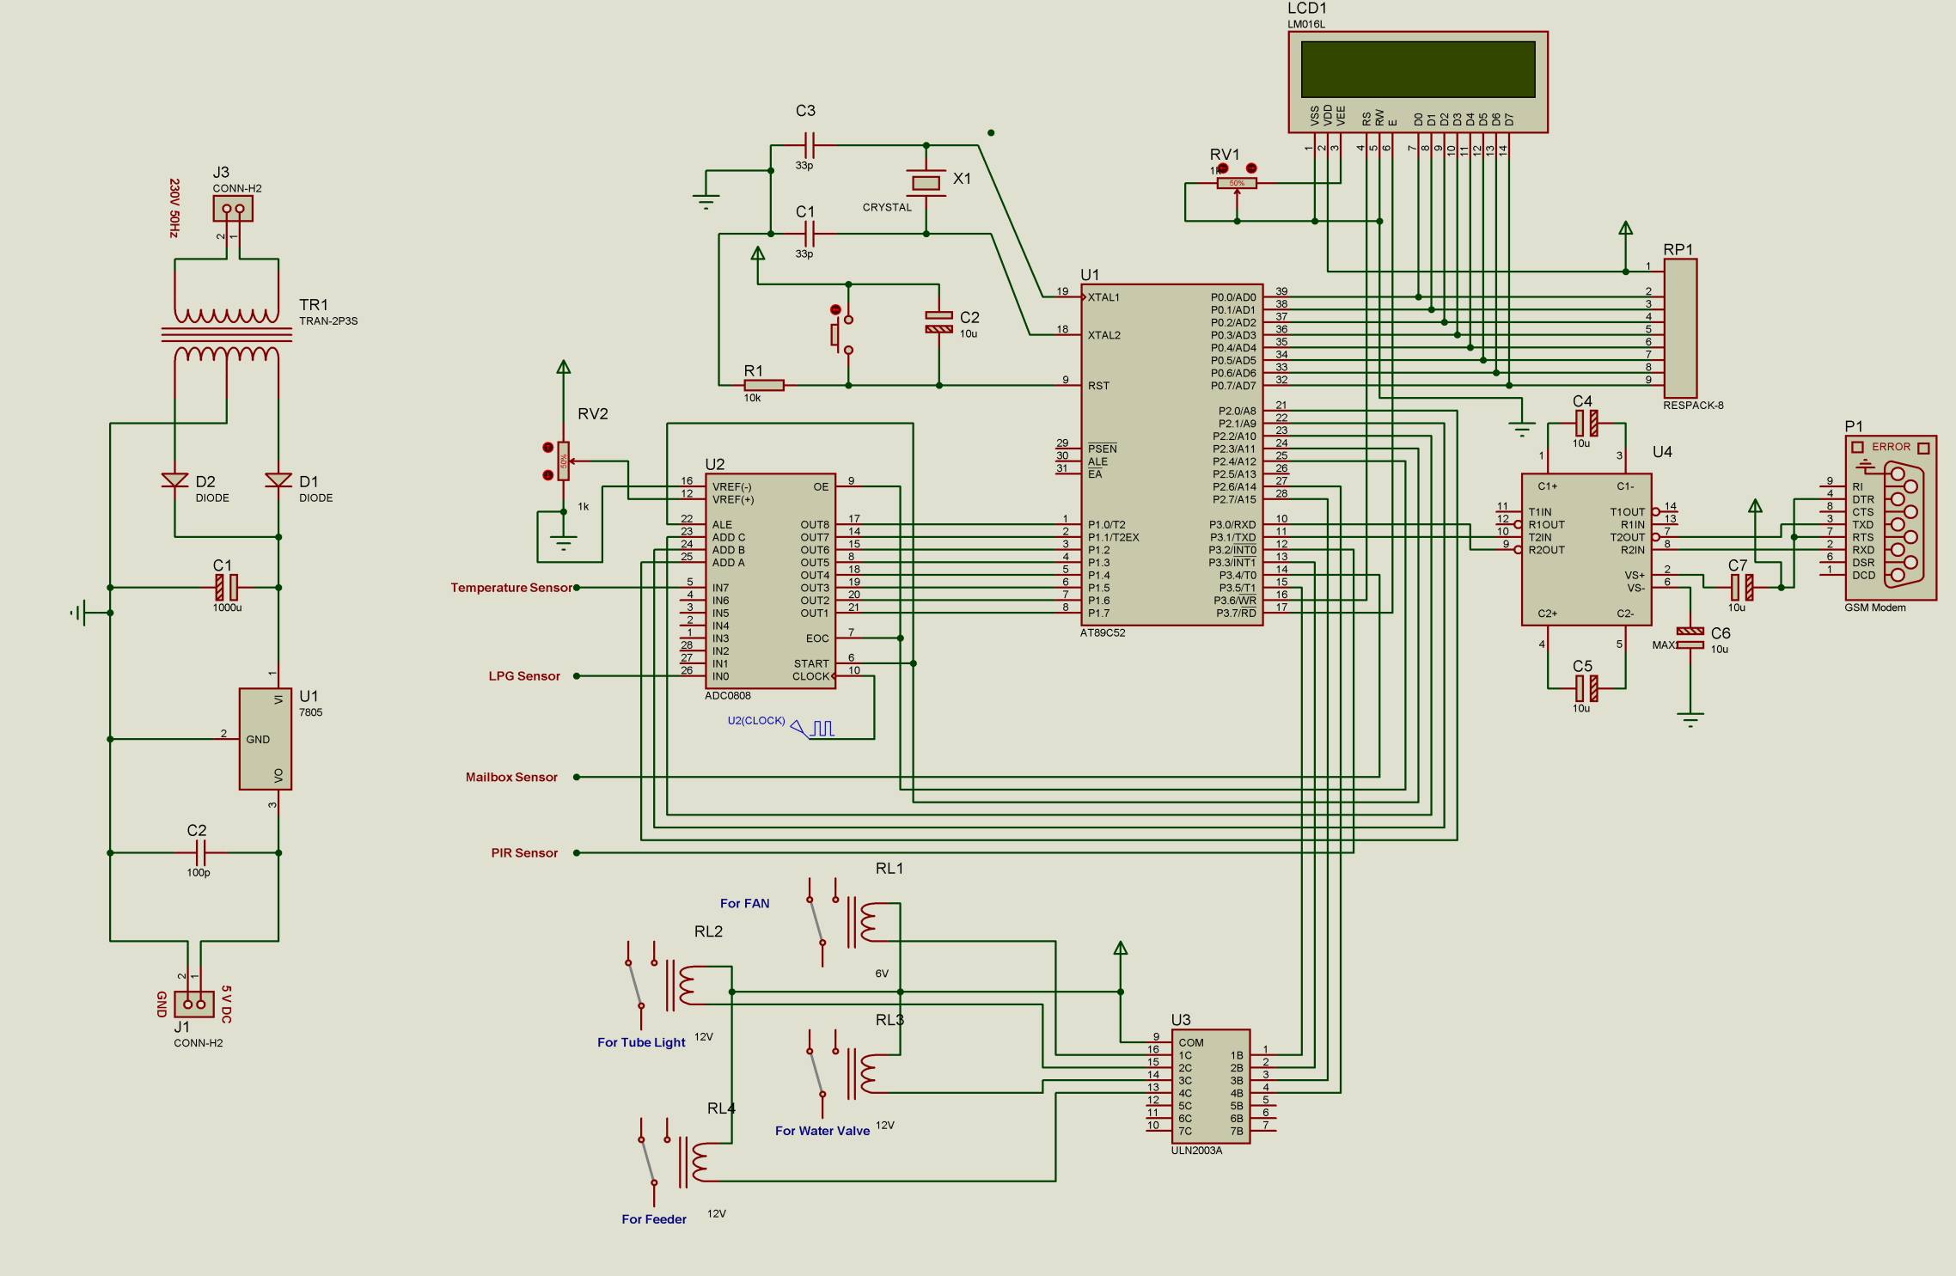

**6.2 Microcontroller-89C52 feature**

* **Pin Diagram :**

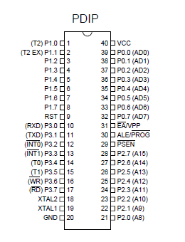

* **Features :**
  + Compatible with MCS-51™ Products
* 8K Bytes of In-System Reprogrammable Flash Memory
* Endurance: 1,000 Write/Erase Cycles
* Fully Static Operation: 0 Hz to 24 MHz
* Three-level Program Memory Lock
* 256 x 8-Bit Internal RAM
* 32 Programmable I/O Lines
* Three 16-bit Timer/Counters
* Eight Interrupt Sources
* Programmable Serial Channel
* Low Power Idle and Power Down Modes
* **Pin Description :**

**VCC:** Supply voltage.

**GND:** Ground.

**Port 0:**

Port 0 is an 8-bit open drain bidirectional I/O port. As an output port, each pin can sink eight TTL inputs. When 1s are written to port 0 pins, the pins can be used as high impedance inputs.Port 0 can also be configured to be the multiplexed loworder address/data bus during accesses to external program and data memory. In this mode, P0 has internal pullups. Port 0 also receives the code bytes during Flash programming and outputs the code bytes during program verification. External pullups are required during program verification.

**Port 1:**

Port 1 is an 8-bit bidirectional I/O port with internal pullups. The Port 1 output buffers can sink/source four TTL inputs. When 1s are written to Port 1 pins, they are pulled high by the internal pullups and can be used as inputs. As inputs, Port 1 pins that are externally being pulled low will source current (IIL) because of the internal pullups. In addition, P1.0 and P1.1 can be configured to be the timer/counter 2 external count input (P1.0/T2) and the timer/counter 2 trigger input (P1.1/T2EX), respectively, as shown in the following table. Port 1 also receives the low-order address bytes during Flash programming and verification.

**Port Pin Alternate Functions**

P1.0 T2 (external count input to Timer/Counter 2),clock-out

P1.1 T2EX (Timer/Counter 2 capture/reload trigger and direction control

**Port 2:**

Port 2 is an 8-bit bidirectional I/O port with internal pullups. The Port 2 output buffers can sink/source four TTL inputs. When 1s are written to Port 2 pins, they are pulled high by

the internal pullups and can be used as inputs. As inputs, Port 2 pins that are externally being pulled low will source current (IIL) because of the internal pullups. Port 2 emits the high-order address byte during fetches from external program memory and during accesses to

external data memory that use 16-bit addresses (MOVX @ DPTR). In this application, Port 2 uses strong internal pull-ups when emitting 1s. During accesses to external data memory that use 8-bit addresses (MOVX @ RI), Port 2 emits the contents of the P2 Special Function Register. Port 2 also receives the high-order address bits and some control signals during Flash programming and verification.

**Port 3:**

Port 3 is an 8-bit bidirectional I/O port with internal pullups. The Port 3 output buffers can sink/source four TTL inputs. When 1s are written to Port 3 pins, they are pulled high by the internal pullups and can be used as inputs. As inputs, Port 3 pins that are externally being pulled low will source current (IIL) because of the pullups. Port 3 also serves the functions of various special feature of the AT89C51, as shown in the following table. Port 3 also receives some control signals for Flash programming and verification.

**Port Pin Alternate Functions:**

P3.0 RXD (serial input port)

P3.1 TXD (serial output port)

P3.2 INT0 (external interrupt 0)

P3.3 INT1 (external interrupt 1)

P3.4 T0 (timer 0 external input)

P3.5 T1 (timer 1 external input)

P3.6 WR (external data memory write strobe)

P3.7 RD (external data memory read strobe)

**RST:**

Reset input. A high on this pin for two machine cycles while the oscillator is running resets the device.

**ALE/PROG:**

Address Latch Enable is an output pulse for latching the low byte of the address during accesses to external memory. This pin is also the program pulse input (PROG) during

Flash programming. In normal operation, ALE is emitted at a constant rate of 1/6 the oscillator frequency and may be used for external timing or clocking purposes. Note, however, that one ALE pulse is skipped during each access to external data memory.

If desired, ALE operation can be disabled by setting bit 0 of SFR location 8EH. With the bit set, ALE is active only during a MOVX or MOVC instruction. Otherwise, the pin is weakly pulled high. Setting the ALE-disable bit has no effect if the microcontroller is in external execution mode.

**PSEN:**

Program Store Enable is the read strobe to external program memory. When the AT89C52 is executing code from external program memory, PSEN is activated twice each machine cycle, except that two PSEN activations are skipped during each access to external data memory.

**EA/VPP:**

External Access Enable. EA must be strapped to GND in order to enable the device to fetch code from external program memory locations starting at 0000H up to FFFFH. Note, owever, that if lock bit 1 is programmed, EA will be internally latched on reset. EA should be strapped to VCC for internal program executions. This pin also receives the 12-volt programming enable voltage (VPP) during Flash programming when 12-volt programming is selected.

**XTAL1:**

Input to the inverting oscillator amplifier and input to the internal clock operating circuit.

**XTAL2:**

Output from the inverting oscillator amplifier.

**Data Memory:**

The AT89C52 implements 256 bytes of on-chip RAM. The upper 128 bytes occupy a parallel address space to the Special Function Registers. That means the upper 128 bytes have the same addresses as the SFR space but are physically separate from SFR space. When an instruction accesses an internal location above address 7FH, the address mode used in the instruction specifies whether the CPU accesses the upper 128 bytes of RAM or the SFR space. Instructions that use direct addressing access SFR space. For example, the following direct addressing instruction accesses the SFR at location 0A0H (which is P2).

MOV 0A0H, #data. Instructions that use indirect addressing access the upper 128 bytes of RAM. For example, the following indirect addressing instruction, where R0 contains 0A0H, accesses the data byte at address 0A0H, rather than P2 (whose address is 0A0H).

MOV @R0, #data Note that stack operations are examples of indirect addressing, so the upper 128 bytes of data RAM are available as stack space.

**Timer 0 and 1:**

Timer 0 and Timer 1 in the AT89C52 operate the same way as Timer 0 and Timer 1 in the AT89C51.

**Timer 2:**

Timer 2 is a 16-bit Timer/Counter that can operate as either a timer or an event counter. The type of operation is selected by bit C/T2 in the SFR T2CON (shown in Table 2). Timer 2 has three operating modes: capture, auto-reload (up or down counting), and baud rate generator. The modes are selected by bits in T2CON, as shown in Table 3. Timer 2 consists of two 8-bit registers, TH2 and TL2. In the Timer function, the TL2 register is incremented every machine cycle. Since a machine cycle consists of 12 oscillator periods, the count rate is 1/12 of the oscillator frequency.

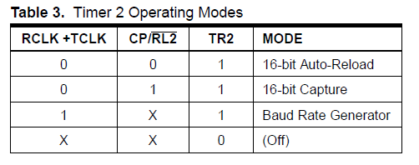

Timer 2 Operating Modes In the Counter function, the register is incremented in response to a 1-to-0 transition at its corresponding external input pin, T2. In this function, the external input is sampled during S5P2 of every machine cycle. When the samples show a high in one cycle and a low in the next cycle, the count is incremented. The new count value appears in the register during S3P1 of the cycle following the one in which the transition was detected. Since two machine cycles (24 oscillator periods) are required to recognize a 1-to-0 transition,

the maximum count rate is 1/24 of the oscillator frequency. To ensure that a given level is sampled at least once before it changes, the level should be held for at least one full machine cycle.

**Capture Mode:**

In the capture mode, two options are selected by bit EXEN2 in T2CON. If EXEN2 = 0, Timer 2 is a 16-bit timer or counter which upon overflow sets bit TF2 in T2CON. This bit can then be used to generate an interrupt. If EXEN2 = 1, Timer 2 performs the same operation, but a 1-to-0 transition at external input T2EX also causes the current value in TH2 and TL2 to be captured into RCAP2H and RCAP2L, respectively. In addition, the transition at T2EX causes bit EXF2 in T2CON to be set. The EXF2 bit, like TF2, can generate an interrupt. The capture mode is illustrated in Figure 1.

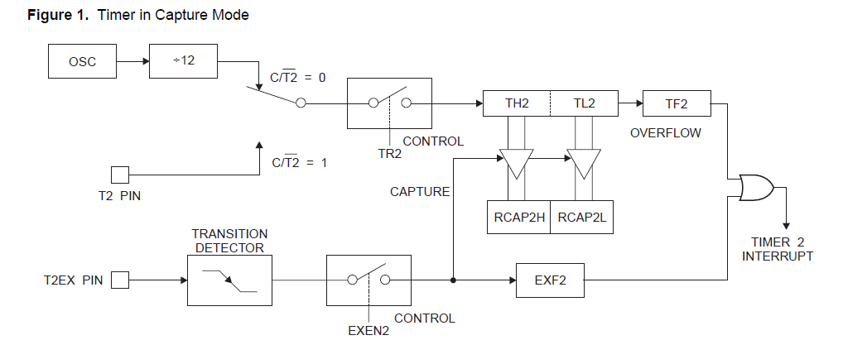

**Auto-reload (Up or Down Counter):**

Timer 2 can be programmed to count up or down when configured in its 16-bit auto-reload mode. This feature is invoked by the DCEN (Down Counter Enable) bit located in the SFR T2MOD (see Table 4). Upon reset, the DCEN bit is set to 0 so that timer 2 will default to count up. When DCEN is set, Timer 2 can count up or down, depending on the value of the T2EX pin. Figure 2 shows Timer 2 automatically counting up when DCEN = 0. In this mode, two options are selected by bit EXEN2 in T2CON. If EXEN2 = 0, Timer 2 counts up to

0FFFFH and then sets the TF2 bit upon overflow. The overflow also causes the timer registers to be reloaded with the 16-bit value in RCAP2H and RCAP2L. The values in

Timer in Capture ModeRCAP2H and RCAP2L are preset by software. If EXEN2 = 1, a 16-bit reload can be triggered either by an overflow or by a 1-to-0 transition at external input T2EX. This transition also sets the EXF2 bit. Both the TF2 and EXF2 bits can generate an interrupt if enabled. Setting the DCEN bit enables Timer 2 to count up or down, as shown in Figure 3. In this mode, the T2EX pin controls the direction of the count. A logic 1 at T2EX makes Timer 2 count up. The timer will overflow at 0FFFFH and set the TF2 bit. This overflow also causes the 16-bit value in RCAP2H and RCAP2L to be reloaded into the timer registers, TH2 and TL2, respectively. A logic 0 at T2EX makes Timer 2 count down. The timer underflows when TH2 and TL2 equal the values stored in RCAP2H and RCAP2L. The underflow sets the TF2 bit and causes 0FFFFH to be reloaded into the timer registers. The EXF2 bit toggles whenever Timer 2 overflows or underflows and can be used as a 17th bit of resolution. In this operating mode, EXF2 does not flag an interrupt.

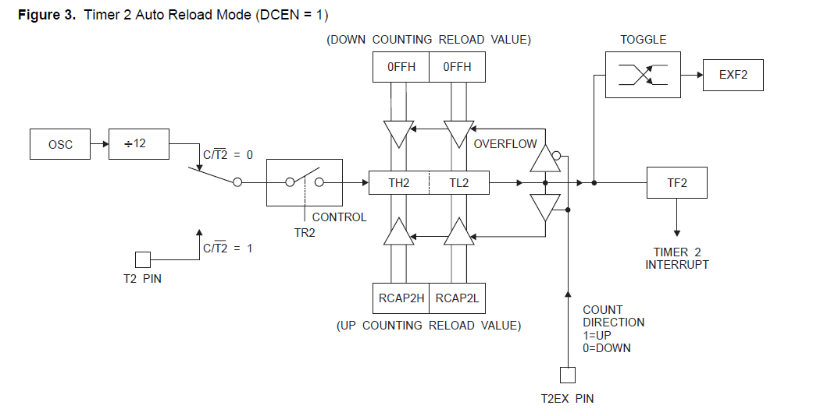

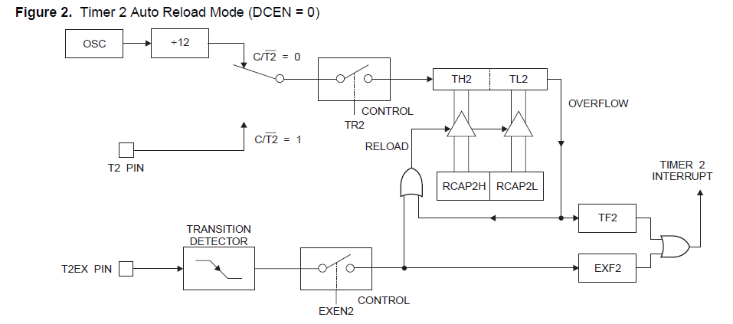

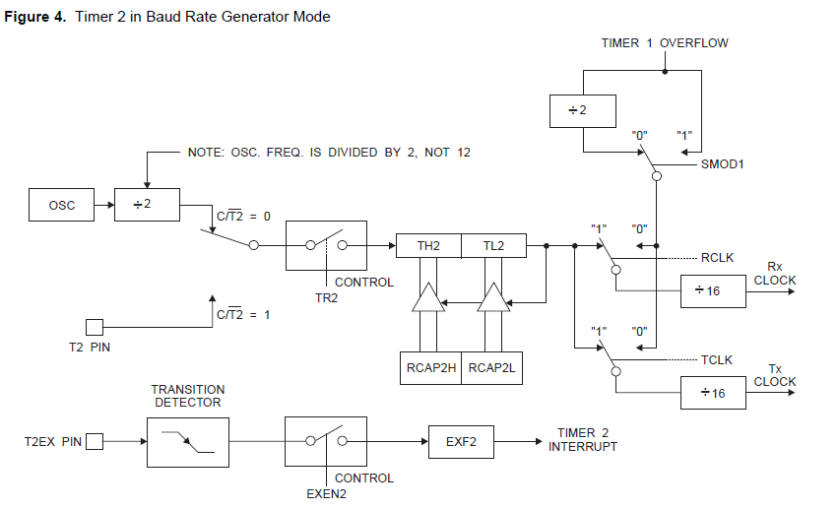

**Baud Rate Generator:**

Timer 2 is selected as the baud rate generator by setting TCLK and/or RCLK in T2CON (Table 2). Note that the baud rates for transmit and receive can be different if Timer 2 is used for the receiver or transmitter and Timer 1 is used for the other function. Setting RCLK and/or TCLK puts Timer 2 into its baud rate generator mode, as shown in Figure 4. The baud rate generator mode is similar to the auto-reload mode, in that a rollover in TH2 causes the Timer 2 registers to be reloaded with the 16-bit value in registers RCAP2H and RCAP2L, which are preset by software.

The baud rates in Modes 1 and 3 are determined by Timer 2’s overflow rate according to the following equation.



The Timer can be configured for either timer or counter operation. In most applications, it is configured for timer operation (CP/T2 = 0). The timer operation is different for Timer 2 when it is used as a baud rate generator. Normally, As a timer, it increments every machine cycle (at 1/12 the oscillator frequency). As a baud rate generator, however, it increments every state time (at 1/2 the oscillator frequency). The baud rate formula is given below.



where (RCAP2H, RCAP2L) is the content of RCAP2H and RCAP2L taken as a 16-bit unsigned integer. Timer 2 as a baud rate generator is shown in Figure 4. This figure is valid only if RCLK or TCLK = 1 in T2CON. Note that a rollover in TH2 does not set TF2 and will not generate an interrupt. Note too, that if EXEN2 is set, a 1-to-0 transition in T2EX will set EXF2 but will not cause a reload from (RCAP2H, RCAP2L) to (TH2, TL2). Thus when Timer 2 is in use as a baud rate generator, T2EX can be used as an extra external interrupt.

Note that when Timer 2 is running (TR2 =1) as a timer in the baud rate generator mode, TH2 or TL2 should not be read from or written to. Under these conditions, the Timer is incremented every state time, and the results of a read or write may not be accurate. The RCAP2 registers may be read but should not be written to, because a write might overlap a reload and cause write and/or reload errors. The timer should be turned off (clear TR2) before accessing the Timer 2 or RCAP2 registers.

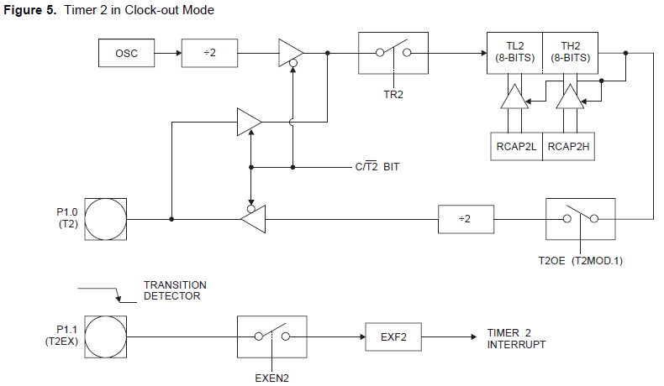

* **6.3 Temperature sensor - (LM-35)**
* **General Description:**

The LM35 series are precision integrated-circuit temperature sensors, whose output voltage is linearly proportional to the Celsius (Centigrade) temperature. The LM35 thus has an advantage over linear temperature sensors calibrated in ° Kelvin, as the user is not required to subtract a large constant voltage from its output to obtain convenient Centigrade scaling. The LM35 does not require any external calibration or trimming to provide typical accuracies of ±1⁄4°C at room temperature and ±3⁄4°C over a full −55 to +150°C temperature range. Low cost is assured by trimming and calibration at the wafer level. The LM35’s low output impedance, linear output, and precise inherent calibration make interfacing to readout or control circuitry especially easy. It can be used with single power supplies, or with plus and

minus supplies. As it draws only 60 μA from its supply, it has very low self-heating, less than 0.1°C in still air. The LM35 is rated to operate over a −55° to +150°C temperature range,

while the LM35C is rated for a −40° to +110°C range (−10° with improved accuracy). The LM35 series is available packaged in hermetic TO-46 transistor packages, while the LM35C, LM35CA, and LM35D are also available in the plastic TO-92 transistor package. The LM35D is also available in an 8-lead surface mount small outline package and a plastic TO-220 package.

* **Features:**
* Calibrated directly in ° Celsius (Centigrade)
* Linear + 10.0 mV/°C scale factor
* 0.5°C accuracy guaranteeable (at +25°C)
* Rated for full −55° to +150°C range
* Suitable for remote applications
* Low cost due to wafer-level trimming
* Operates from 4 to 30 volts
* Less than 60 μA current drain
* Low self-heating, 0.08°C in still air
* Nonlinearity only ±1⁄4°C typical
* Low impedance output, 0.1 W for 1 mA load
* **Typical Applications:**

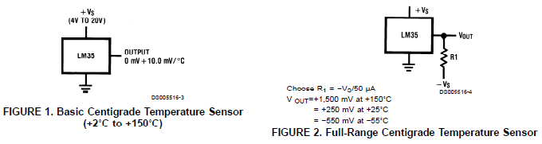

* **Connection Diagrams:**

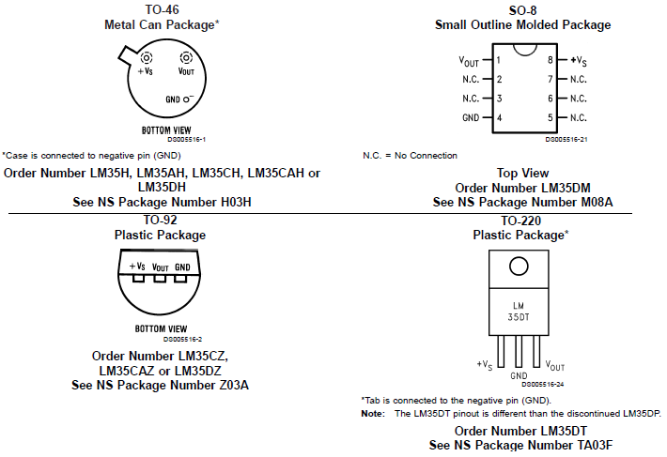

**6.4 LPG gas sensor - MQ-6**

* **FEATURES:**
* High sensitivity to LPG, iso-butane, propane
* Small sensitivity to alcohol, smoke.
* Fast response .
* Stable and long life
* Simple drive circuit
* **APPLICATION:**

They are used in gas leakage detecting equipments in family and industry, are suitable for detecting of LPG, iso-butane, propane, LNG, avoid the noise of alcohol and cooking fumes and cigarette smoke.

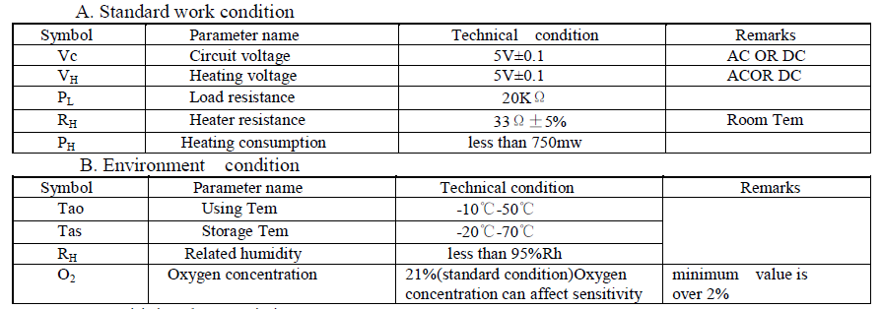

Structure and configuration of MQ-6 gas sensor is shown as Fig. 1 (Configuration A or B), sensor composed by micro AL2O3 ceramic tube, Tin Dioxide (SnO2) sensitive layer, measuring electrode and heater are fixed into a crust made by plastic and stainless steel net. The heater provides necessary work conditions for work of sensitive components. The enveloped MQ-6 have 6 pin ,4 of them are used to fetch signals, and other 2 are used for providing heating current.

* **SENSITVITY ADJUSTMENT:**

Resistance value of MQ-6 is difference to various kinds and various concentration gases. So, When using this components, sensitivity adjustment is very necessary. We recommend that you calibrate the detector for 1000ppm of LPG concentration in air and use value of Load resistance ( RL) about 20KΩ(10KΩ to 47KΩ). When accurately measuring, the proper alarm point for the gas detector should be determined after considering the temperature and humidity influence.

* Structure and configuration, basic measuring circuit

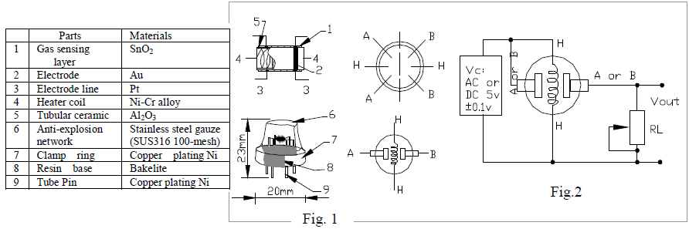

**6.5 PIR –sensor**

The Passive InfraRed (PIR) sensor will, under typical conditions, detect a human being moving around within approximately 10m from the sensor. This is an average value, as the actual detection range is between 5m and 12m. As the performance of the sensor is determined primarily by environmental conditions. No guarantees can be offered regarding the detection range. However, the range is typically sufficient for the majority of interior spaces. Some garages may be large enough that one sensor cannot cover that whole area – we suggest testing this in the actual environment if there’s any doubt. The sensor has a horizontal 110° vertical 60° field of view. The main blind spots are above, below or behind the sensor itself. Typically, the ideal placement in an environment is the upper corner of a room, facing slightly towards the ground (perhaps 20‐25°, depending on the height of the sensor). Try to cover typical paths through the room, focusing particularly on likely entry and exit points. If

the room has several entry points, try to cover as many of these as practicable. A visible PIR motion sensor can be a great deterrent to intruders – but on the other hand, skilled intruders can avoid obviously visible sensors. Try to mix it up a bit.

**Installing wireless PIR sensors:**

Installation height is about 2.2 meters above ground and you need consider the best coverage. Do not install the PIR sensors in direct sunlight or near any device which emits heat or cold, such as air conditioners, refrigerators, ovens, heaters, microwaves or other electronic equipment which generates heat as a by‐product of operation. Replace the batteries in the units regularly.

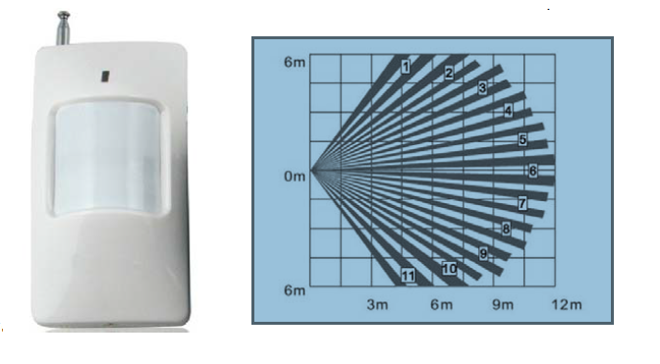

* **Technical Parameters:**
* Power Supply: DC9V (inner 9V battery)
* Static Current: ≤100 mA
* Transmission Current: ≤20mA
* Frequency: 433MHZ
* Transmission Distance: less 80M
* Detective Speed: 0.3 ‐ 3m/s
* Detective Distance: 5 – 12M
* Detective Range: Horizontal 110° Vertical 60°
* Working Condition: Temperature –10 ℃+ 40 ℃
* Humidity ≤ 90 rh

**6.6 IR Sensor**

* **General Discription :**

IE-0530 HP is a super high output power GaAlAs infrared light emitting diode mounted in a clear epoxy end looking packet. it emits narrow band of radiation peaking at 940nm.

* **IR Transmitter ( IE-0530HP )**
* **FEATURES:**
* IE-0530HP Super output GaAlAs IR lightemitting diode
* Capable of pulse operation
* High output power
* Low cost

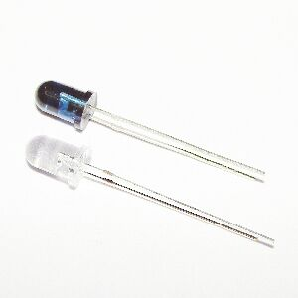

* **IR Receiver ( PIC-2060SMB ) 1**
* **FEATURES:**
* Miniature size
* Continuous signal acceptable
* Black metal cover
* Suitable for R-C oscillator transmitter

**6.7 GSM Modem**

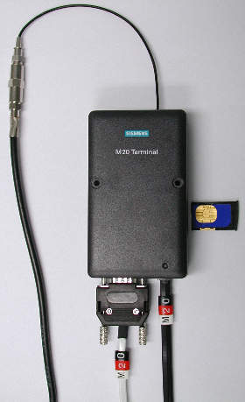

* **FEATURES:**
  + SIM card holder supporting 1.8 V and 3 V card type.
  + MMCX Interface connector for RF output (50 Ohm connector MMCX
  + Edge Mount SMD J01341A0081.
  + 60 pin board-to-board connector (CVILUX CBRB060PC2000R0): Audio (2x analog, 1x digital), I2C bus, SPI bus, 2x ADC, 2x analog out (PWM),12 GPIOs.
  + 1 UART serial port.
* **General Description :**
* Start up and initialization:

A complete start up can take place only with a SIM-card with disabled PIN-check. For a SIM-card with enabled PINM check the most commands are answered with +CME ERROR: SIM-PIN requested. After entering PIN via +CPIN command, which allows a start up completion, a lot of SIM-files will be read; it is possible that some commands are affected for a few seconds. The serial interface driver does not allow a new command, until the old one is terminated by OK or +CME ERROR: <error>. If at start up the MS detects

Inconsistencies related to the NVRAM the following message is displayed: “! NVR DOES NOT FIT TO SWVERSION. NVR-update is needed!”

* General commands:

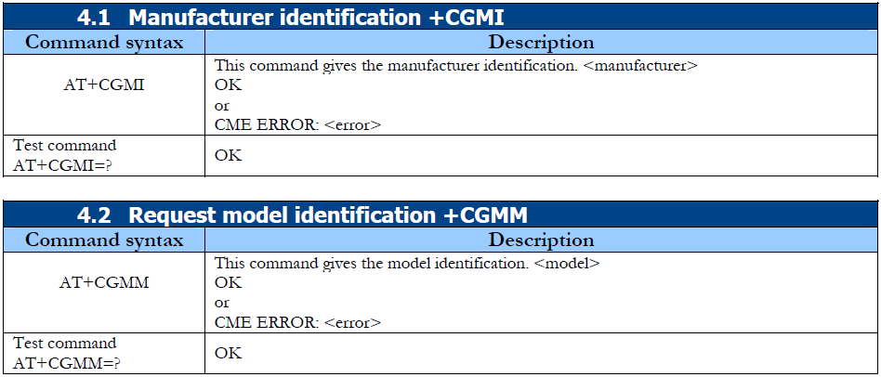

**4.1 Manufacturer identification +CGMI**

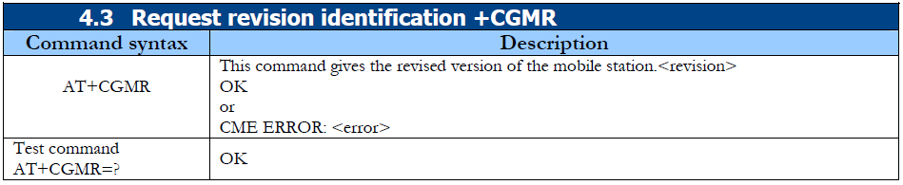

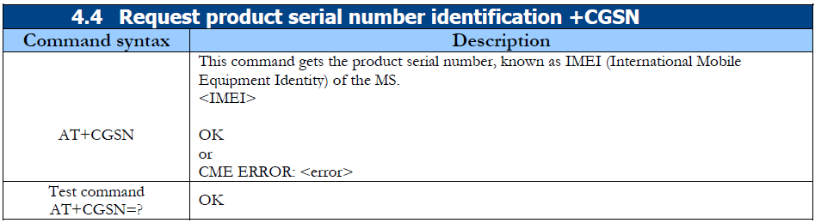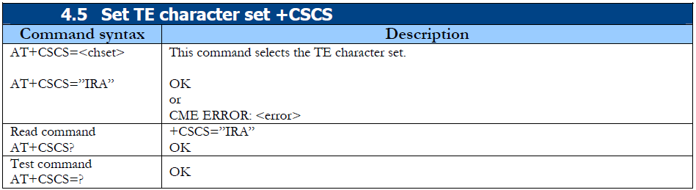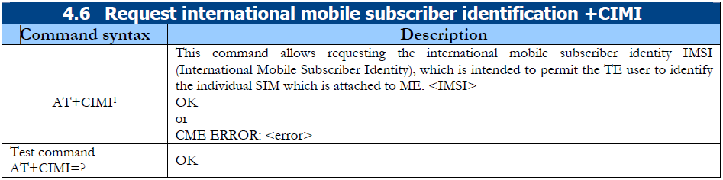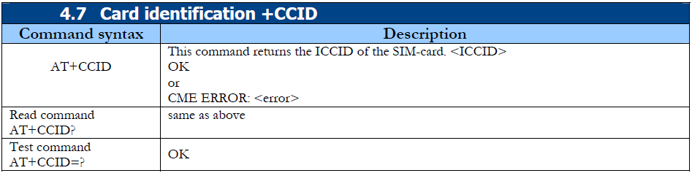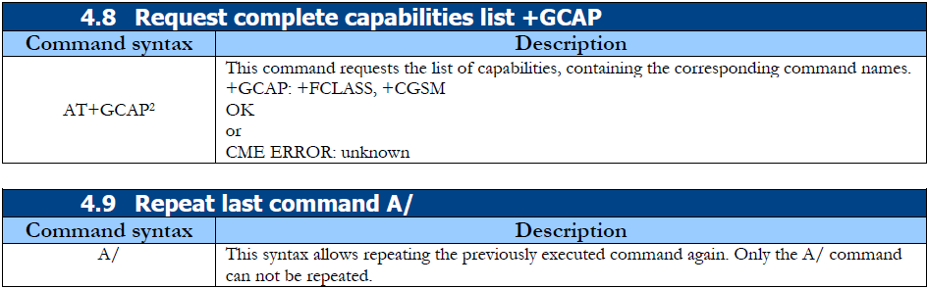

**6.8 ADC**

* **Features:**
* Easy interface to all microprocessors
* Operates ratiometrically or with 5 VDC or analog span
* adjusted voltage reference
* No zero or full-scale adjust required
* 8-channel multiplexer with address logic
* 0V to 5V input range with single 5V power supply
* Outputs meet TTL voltage level specifications
* Standard hermetic or molded 28-pin DIP package
* 28-pin molded chip carrier package
* ADC0808 equivalent to MM74C949
* ADC0809 equivalent to MM74C949-1
* **Key Specifications :**
* Resolution 8 Bits
* n Total Unadjusted Error ±1⁄2 LSB and ±1 LSB
* n Single Supply 5 VDC
* n Low Power 15 mW
* n Conversion Time 100 μs
* **Functional Description:**

**Multiplexer.** The device contains an 8-channel single-ended analog signal multiplexer. A particular input channel is selected by using the address decoder. Table 1 shows the input states for the address lines to select any channel. The address is latched into the decoder on the low-to-high transition of the address latch enable signal.

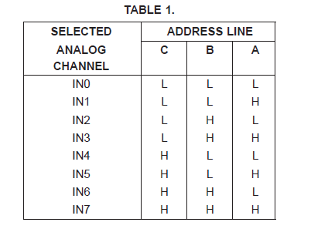

* **Block Diagram:**

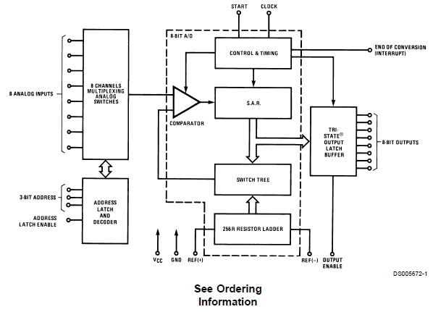

* **Pin Description :**

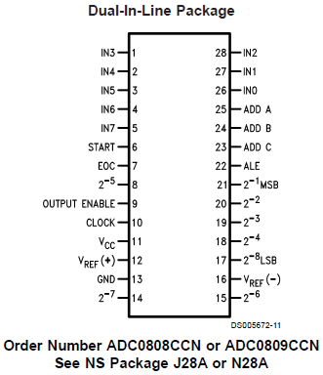

* **CONVERTER CHARACTERISTICS:**

**The Converter**

The heart of this single chip data acquisition system is its 8-bit analog-to-digital converter. The converter is designed to give fast, accurate, and repeatable conversions over a wide range of temperatures. The converter is partitioned into 3 major sections: the 256R ladder network, the successive approximation register, and the comparator. The converter’s digital outputs are positive true.

The 256R ladder network approach (Figure 1) was chosen over the conventional R/2R ladder because of its inherent monotonicity, which guarantees no missing digital codes. Monotonicity is particularly important in closed loop feedback control systems. A non-monotonic relationship can cause oscillations that will be catastrophic for the system. Additionally, the 256R network does not cause load variations on the reference voltage.

The bottom resistor and the top resistor of the ladder network in Figure 1 are not the same value as the remainder of the network. The difference in these resistors causes the output characteristic to be symmetrical with the zero and full-scale points of the transfer curve. The first output transition occurs when the analog signal has reached +1⁄2 LSB and succeeding output transitions occur every 1 LSB later up to full-scale.

The successive approximation register (SAR) performs 8 iterations to approximate the input voltage. For any SAR type converter, n-iterations are required for an n-bit converter. Figure 2 shows a typical example of a 3-bit converter. In the ADC0808, ADC0809, the approximation technique is extended to 8 bits using the 256R network.

The A/D converter’s successive approximation register (SAR) is reset on the positive edge of the start conversion (SC) pulse. The conversion is begun on the falling edge of the start conversion pulse. A conversion in process will be interrupted by receipt of a new start conversion pulse. Continuous conversion may be accomplished by tying the end-of-conversion (EOC) output to the SC input. If used in this mode, an external start conversion pulse should be applied after power up. End-of-conversion will go low between 0 and 8 clock pulses after the rising edge of start conversion.

The most important section of the A/D converter is the comparator. It is this section which is responsible for the ultimate accuracy of the entire converter. It is also the comparator drift which has the greatest influence on the repeatability of the device. A chopper-stabilized comparator provides the most effective method of satisfying all the converter requirements.

The chopper-stabilized comparator converts the DC input signal into an AC signal. This signal is then fed through a high gain AC amplifier and has the DC level restored. This technique limits the drift component of the amplifier since the drift is a DC component which is not passed by the AC amplifier. This makes the entire A/D converter extremely insensitive to temperature, long term drift and input offset errors. Figure 4 shows a typical error curve for the ADC0808 as measured using the procedures outlined in AN-179.

**6.9 LCD Display**

* **Features:**
* 5 x 8 dots with cursor
* Built-in controller (KS 0066 or Equivalent)
* + 5V power supply (Also available for + 3V)
* 1/16 duty cycle
* B/L to be driven by pin 1, pin 2 or pin 15, pin 16 or A.K (LED)
* N.V. optional for + 3V power supply

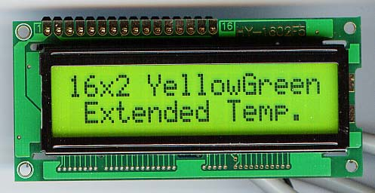

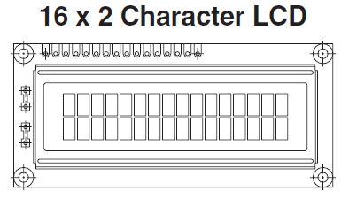

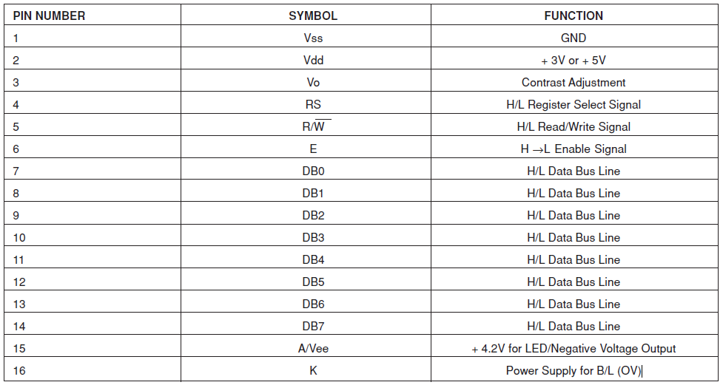

**6.10 Relay driver IC (ULN2003A)**

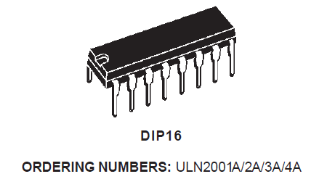

* **Features:**
* Seven Darlington packets
* Output vtg is 50v (600mA peak)
* Output current 500mA per driver
* Integrated suppression diode for inductive load.
* Output can be paralleled for the higher current.
* TTL/CMOS/PMOS/DTL compatible inputs.
* Input pinned opposite outputs to simplify layout.
* **DESCRIPTION:**

The ULN2001A, ULN2002A, ULN2003 and ULN2004Aare high voltage,high current darlington arrays each containing seven open collector darlington pairs with common emitters. Each channel rated at 500mAand can withstand peak currents of 600mA. Suppression diodes are included for inductive load driving and the inputs are pinned opposite

the outputs to simplify board layout.

The four versions interface to all common logic families:

: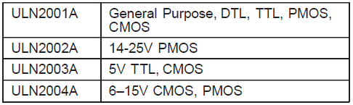

These versatile devices are useful for driving a wide range of loads including solenoids, relays DC motors, LED displays filament lamps, thermal print heads and high power buffers. The ULN2001A/2002A/2003Aand 2004Aare supplied in 16 pin plastic DIP packages with a copper lead frame to reduce thermal resistance. They are available also in small outline package (SO-16) as ULN2001D/2002D/2003D/2004D.

* **PIN CONNECTION** :

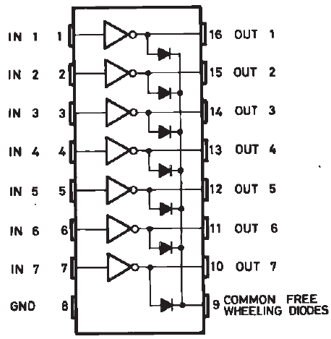

**6.11 Relay**



* **Features:**
* Subminiature “sugar cube” relay with universal terminal footprint.
* Conforms to VDE0435 (VDE approval: B250 Insulation grade), UL508, CSA22.2.
* Tracking resistance: CTI>250 (-VD type).
* UL class-F coil insulation model available (UL class-B coil insulation for standard model).
* High switching power: 10 A.
* Two types of seal available; flux protection and fully sealed.
* Withstands impulse of up to 4,500 V.
* 400-mW and 360-mW coil power consumption types available.
* Pre-soldered terminals.

**6.12 RS 232 Interface**

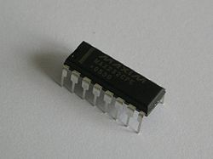

* **General Description:**

The MAX202E–MAX213E, MAX232E/MAX241E line drivers/receivers are designed for RS-232 and V.28 communications in harsh environments. Each transmitter output and receiver input is protecte against ±15kV electrostatic discharge (ESD) shocks,

without latchup. The various combinations of features are outlined in the Selection Guide. The drivers and receivers for all ten devices meet all EIA/TIA-232E and CCITT V.28 specifications at data rates up to 120kbps, when loaded in accordance with the EIA/TIA-232E

specification.

The MAX211E/MAX213E/MAX241E are available in 28- pin SO packages, as well as a 28-pin SSOP that uses 60% less board space. The MAX202E/MAX232E come in 16-pin narrow SO, wide SO, and DIP packages. The MAX203E comes in a 20-pin DIP/SO package, and needs no external charge-pump capacitors. Then MAX205E comes in a 24-pin wide DIP package, and also eliminates external charge-pump capacitors. The MAX206E/MAX207E/MAX208E come in 24-pin SO, SSOP, and narrow DIP packages. The MAX232E/MAX241E operate with four 1μF capacitors, while the MAX202E/MAX206E/MAX207E/MAX208E/MAX211E/ MAX213E operate with four 0.1μF capacitors, further reducing cost and board space.

* **Pin Configurations:**

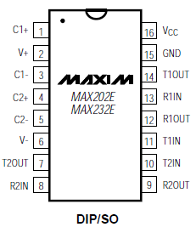

* **Features:**
* ESD Protection for RS-232 I/O Pins:

±15kV—Human Body Model

±8kV—IEC1000-4-2, Contact Discharge

±15kV—IEC1000-4-2, Air-Gap Discharge

* Latchup Free (unlike bipolar equivalents)
* Guaranteed 120kbps Data Rate—LapLink™ Compatible
* Guaranteed 3V/μs Min Slew Rate
* Operate from a Single +5V Power Supply

**6.13 PCB Layout**

**7. SOFTWARE SECTION**

**7.1 Algorithm**

* Main Program:

1. Start.
2. ‘OFF’ All the appliances.
3. Initialize LCD Display for the displaying status of appliances.
4. Initialize the Serial Communication for the transmission and reception of the instruction from controller or Sender
5. Display “WELCOME TO HOME” on the LCD display continuously.
6. Initialize Mobile for the message transmission and reception.
7. Display “TEMPARATURE” on the LCD display.
8. Compare “TEMPARATURE” value with the set point.
   1. Is “TEMPARATURE” greater than set point?
   2. If the “TEMPARATURE” is greater than set point send message for “FIRE” and

Tune the buzzer.

* 1. Introduce delay of 5s

1. Compare “LPG Gas” value with the set point.
   1. Is “LPG Gas” greater than set point?
   2. If the “LPG Gas” is greater than set point send message for “LPG Gas Leakage” and

Tune the buzzer.

* 1. Introduce delay of 5s

10. Compare “MAIL” value with the set point.

10.1 Is “MAIL” preset in the mail box?

10.2 If the “MAIL” is preset in the mail box tune buzzer only do not send the message to

the mobile.

* 1. Introduce delay of 5s

11. Compare “PIR Sensor” value with the set point.

11.1 Is “PIR Sensor” greater than set point?

11.2 If the “PIR Sensor” is greater than set point send message for “INTRODURE IN THE HOME” and tune the buzzer

11.3 Introduce delay of 5s

12. Return to the main program at step “7”.

13. Press the “RESET” switch then go to step “1”.

14. Whenever the power supply is off then the shut down the system.

15. Stop.

* Serial Interrupt Algorithm :

1. Start.
2. Receive characteristics from GSM modem.
3. Skip 53 characteristics from the received data.
4. Compare 54 characteristic with the “1”.
   1. Is data is equal switch “ON” the First appliance.
   2. Otherwise compare with other characteristic.

5. Compare 54 characteristic with the “2”.

* 1. Is data is equal switch “OFF” the First appliance.
  2. Otherwise compare with other characteristic.

6. Compare 54 characteristic with the “3”.

* 1. Is data is equal switch “ON” the Second appliance.
  2. Otherwise compare with other characteristic.

1. Compare 54 characteristic with the “4”.
   1. Is data is equal switch “OFF” the Second appliance.
   2. Otherwise compare with other characteristic.
2. Compare 54 characteristic with the “5”.
   1. Is data is equal switch “ON” the Third appliance.
   2. Otherwise compare with other characteristic.
3. Compare 54 characteristic with the “6”.
   1. Is data is equal switch “OFF” the Third appliance.
   2. Otherwise compare with other characteristic.
4. Compare 54 characteristic with the “7”.
   1. Is data is equal switch “ON” the Forth appliance.
   2. Otherwise compare with other characteristic.
5. Compare 54 characteristic with the “8”.
   1. Is data is equal switch “OFF” the Forth appliance.
   2. Otherwise compare with other characteristic.
6. Compare 54 characteristic with the “9”.
   1. Is data is equal switc h“ON” the All appliance.
   2. Otherwise compare with other characteristic.
7. Compare 54 characteristic with the “0”.
   1. Is data is equal switch “OFF” the All appliance.
   2. Otherwise compare with other characteristic.
8. Return to main program.

**7.2 Flow Chart**

* Main Program:

Start

“OFF” All Appliances of the home which want to control

Initialize LCD Display for the displaying status of appliances.

Initialize the Serial Communication for the transmission and reception

Display “WELCOME TO HOME” on the LCD display continuously.

Initialize Mobile for the message transmission and reception.

Take a Input from Temperature sensor as i/p

Display “TEMPARATURE” on the LCD display.

Compare Sensor Input data with the set point

send message for “FIRE” and Tune the buzzer.

Is I/P greater ?

No

Introduce delay of 5s

Yes

Take a Input from LPG Gas sensor as input data

Display “LPG Gas ” leakage level on the LCD display.

Compare Sensor Input data with the set point

Send message for “LPG Gas Leakage” and Tune the buzzer.

Is LPG Gas leak?

Yes

Introduce delay of 5s

No

Display “MAIL” preset in the mail box” on the LCD display.

Take a Input from Mail sensor as input data

Compare Sensor Input data with the set point

tune buzzer only do not send the message to the mobile.

Is Mail present?

Yes

Introduce delay of 5s

No

Take a Input from PIR sensor as input data

Display “PIR Sensor” level on the LCD display.

Compare Sensor Input data with the set point

send message for “ INTRODURE IN THE HOME” and tune the buzzer

Is PIR I/P greater ?

yes

Introduce delay of 5s

No

* Serial Interrupt flow chart:

Compare 54 characteristic with the “1”.

Skip 53 characteristics from the received data.

Receive characteristics from GSM modem.

Start

Is 54th data “1”?

Yes

Is data is equal switch “ON” the First appliance.

No

Is 54th data “2”?

Is data is equal switch “OFF” the First appliance.

Yes

No

Is 54th data “3”?

Yes

Is data is equal switch “ON” the Second appliance.

No

No

Is 54th data “4”?

Is data is equal switch “OFF” the Second appliance.

Yes

No

Is data is equal switch “ON” the Third appliance.

Is 54th data “9”?

Is 54th data “8”?

Is 54th data “7”?

Is 54th data “5”?

Yes

No

Yes

Return to the main program

Is data is equal switch “OFF” the Third appliance.

Is 54th data “6”?

Is data is equal switch “ON” the All appliance.

Is data is equal switch “OFF” the Forth appliance.

Is data is equal switch “ON” the Forth appliance.

No

Yes

No

Yes

No

Yes

No

Is data is equal switch “OFF” the All appliance.

Is 54th data “0”?

Yes

No

Yes

Return to the main program

**8. TESTING DIFFICULTIES & MANAGEMENT**

* TESTING DIFFICULTIES:
* There are many sensors are used in the project, there for at the output of sensors is very difficult to take the reading. Hence every time sensors output changes continuously, it is difficult to make constant.
* Program is very long due to the numbers of comparisons, condition checking and conditions applying in the program.
* There is many more initialization of the different appliances for different conditions are difficult in the programming.
* At the some point we are not get the proper level of voltage i.e. less voltage than the excepted output voltage.
* MANAGEMENT:
* To check every point output voltage/current, if this is less than the expected voltage/current, then amplifies this voltage/current at specific level.
* Program having many more initializing of the programs, hence to separate all the programs and make it as the separate subroutine programs, hence depending upon the requirement call the subroutine.
* Make all the connection well soldered i.e. no discontinuity in the connected points present in the circuit.

**9. ADVANTAGES & DISADVANTAGES**

* **ADVANTAGES :**
* We can get all the status about home appliances on users GSM mobile handset.
* It is economical system , Hence common people can takes the advantage of that system.
* It is not necessary every time to check present working condition of every appliances, it’s user friendly.
* It is best control of home appliances, giving the command through SMS by using Mobile handset.
* Using this system we can provide best security to our home.
* Using this system we can save the Energy, Time and Money for features life.
* **Disadvantages:**
* We are detect only the LPG gas leakage, But we did not control the leakage.

**10. APPLICATIONS AND FUTURE SCOPE**

* **Applications :**
* Can be used in
* Home Automation
* Industrial Automation
* Hospital and Hotel Automation
* Security system in the markets, BIG bazaar, Supermarkets as well as in banks etc.
* **FUTURE SCOPE:**
* Comfortable lifestyle
* All time Security
* Save valuable Time
* Save Man power and Money
* Reliable Controlling through GSM
* Can be used as Automated systems in offices, bank, hospitals, hostels and

Military control rooms.

1. **CONCLUSION**

This system is an absolute solution over today’ common people “Home Automation” systems which increases the resolution, accuracy by using microcontroller and also is user compatible.

As microcontroller 89S52 is implemented in the system controlling of all appliances present in the house by only sending message to controller.

Many more parameters, which will help user for keeping safe and secure, when user is far away from the home.

Definitely such system will provide the safe & problem less in the home.

.

**12. REFERENCES**

* . [www.electronicsforyou.com](http://www.electronicsforyou.com)
* 2. [www.gsmmodems.com](http://www.gsmmodems.com)
* 3. [www.fmtransreceiver.com](http://www.fmtransreceiver.com)
* 4. [www.efykits.com](http://www.efykits.com)
* 5. [www.efydatasheets.com](http://www.efydatasheets.com)
* 6. [www.wirelesstransmitter.com](http://www.wirelesstransmitter.com)

**13. APPENDIX**

**13.1 PROJECT PICTURE**

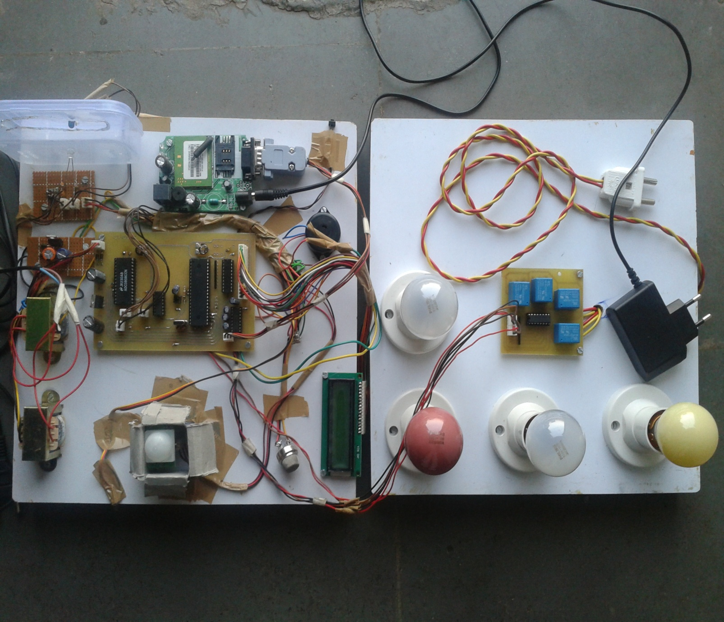

**13.2 COMPONENT LIST**

* Power chord
* Three pin connector, Two pin connectors
* 909 transformer
* Diode 1N4007
* 7805 register
* Preset 10K
* ADC 0808
* 74245 Buffer
* 89S52 Controller
* LM 35
* PIR Sensor
* IR TX/RX
* MQ 6
* GSM modem
* 7490 IC
* Reset switch
* 11.0592 MHz Crystal
* 16*2 LCD display
* 16 pin Double sided Connector
* 4.7 K Resistor array
* 14,16,20,28 & 40 pin IC base
* 1000uf, 1uf & 10uf Capacitors